# **How to make your own thieves-like protective essential oil blend**

## **Array**

Posted on [December 11, 2017](https://personalliberty.com/make-thieves-like-protective-essential-oil-blend/) by [Gaye Levy](https://personalliberty.com/author/gayelevypl/)

12 Shares

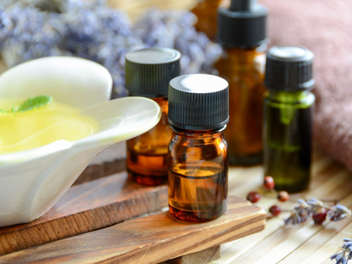

This year, with so many people getting colds, flu, bronchitis and the general creeping crud, I want to share with you a blend you can make yourself using readily available oils. This blend is based on the legendary robbers/thieves blend that is very popular among essential oil enthusiasts.

As the story goes, grave robbers in 15th century England developed a special blend of plant and herb oils and doused themselves with this blend it to avoid getting the plague as they robbed their victims. Sounds gruesome to me, but so goes the legend.

Is it true? As with all legends, there is no way to know for sure. What I do know is that I have not been sick even one since I started using this blend myself.

****DIY Essential Oil Protective Blend****

* 27 drops Clove Bud Oil
* 23 drops Lemon Oil
* 13 drops Cinnamon Bark Oil
* 10 drops Eucalyptus Oil
* 7 drops Rosemary Oil

Add the oils to an empty glass bottle and use as needed. (See my suggestions below). This makes approximately 5ML and is easily doubled or tripled.

## **Can you save money making your own blend?**

I wanted to answer this for myself so I did a cost analysis and learned you can save quite a bit of money by making this blend yourself with one caveat. In order to save money, you need to either already have the oils on hand or plan to use the leftover oils for another purpose. Of course, that other purpose can be to make additional batches of this blend!

Roughly, here is my cost analysis for making your own DIY blend versus purchasing it pre-made. Keep in mind that there are slight variations in each formula.

[Spark Naturals](https://sparknaturals.com/?id=5534" \t "https://personalliberty.com/make-thieves-like-protective-essential-oil-blend/_blank):  DIY $7.86 vs Shield Blend $10.08 for 5ML and $28.80 for 15ML  
[NOW Foods](https://amzn.to/2nqIf20" \t "https://personalliberty.com/make-thieves-like-protective-essential-oil-blend/_blank):  DIY $2.23 vs Natures Shield $12.49 for 30ML  
[Plant Therapy](https://amzn.to/2jMv1aK" \t "https://personalliberty.com/make-thieves-like-protective-essential-oil-blend/_blank):   DIY $4.15 vs Germ Fighter $8.95 for 10ML

Compare these prices with my rough estimate of the cost of Young Living Thieves Oil at $29 for 5ML and $44 for 15ML.

*Note: I happen to use the [Spark Naturals Shield Protective Blend](https://sparknaturals.com/index.php/shield-protective-blend.html?id=5534" \t "https://personalliberty.com/make-thieves-like-protective-essential-oil-blend/_blank). Yes, it is not as inexpensive as some of the other brands but the cost is still reasonable. I trust the consistent quality of Spark Naturals oils and use them exclusively for health and wellness purposes.*

Suggestions for other brand-name blends you may want to explore can be found on the [Essential Oils Resource page of the Strategic Living website](https://strategiclivingblog.com/essential-oil-resources/" \t "https://personalliberty.com/make-thieves-like-protective-essential-oil-blend/_blank).

## **How to use your DIY protective blend**

Now for the good part. Once you have your protective essential oil blend, how do you use it? I am sharing how I personally use this blend to keep the cooties at bay.

****In a diffuser:****This time of year, I diffuse six to eight drops in the diffusers I have scattered all over the house.

****Hand sanitizer:****I keep a small spray bottle with witch hazel and my protective thieves-like blend in my handbag and use it as a mobile hand sanitizer. This is especially useful when leaving public restrooms that do not have paper towels that can be used to open germ-laden exit doors. I hate those blower thingies! A little goes a long way. In my 1-ounce spray bottle, I use 20 drops of essential oil. Sometimes I also add a couple of drops of oregano oil for additional antibacterial protection.

****Protective salve:****Instead of adding rosemary, lavender and peppermint to my healing salve, I add the requisite number of drops of my protective blend. So, for example, I will add 30 drops of the protective blend to a 1-ounce jar of salve. If I have been around sniffly, stuffed-up and sickly people, I will rub this on the bottom of my feet morning and night to chase away the cooties. [Here is how to make your own healing salve.](https://strategiclivingblog.com/awesome-healing-skin-salve/" \o "https://strategiclivingblog.com/awesome-healing-skin-salve/" \t "https://personalliberty.com/make-thieves-like-protective-essential-oil-blend/_blank)

****Foaming soap:****In my foaming soap dispenser, I add 12 drops of the protective blend to 2 ounces of castile soap and 10 ounces of water.  That way I get the benefit of sanitized hands each and every time I wash them (which is often).

****Cleaning supplies:****Finally, I like to add this blend to my homemade cleaning supplies to give them a germ-fighting boost. Adding a few drops to a 50/50 solution of vinegar and water solution makes for a fine bathroom cleaner all by its own self.

## **Summing it all up**

I hope you will consider whipping up a batch of your own protective essential oil blend, or alternatively, purchase [Shield Protective blend](https://sparknaturals.com/index.php/shield-protective-blend.html?id=5534" \t "https://personalliberty.com/make-thieves-like-protective-essential-oil-blend/_blank) or another like it. This stuff can really give you the edge in terms of staying healthy not only during cold and flu season but all year round.

If you enjoyed this article and interested in learning more about essential oils, you can join the Strategic Living Essential Oil VIP list using this link: [http://eepurl.com/dbHLEz](http://eepurl.com/dbHLEz" \o "http://eepurl.com/dbHLEz" \t "https://personalliberty.com/make-thieves-like-protective-essential-oil-blend/_blank)